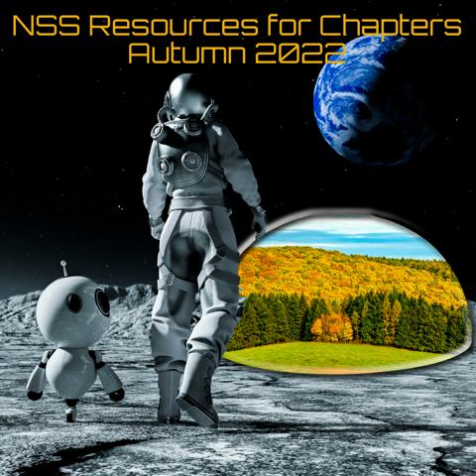
Greetings from Ed, Perri and Kris
Here is the Latest Chapters Resources List. We hope it helps you and your chapter to:
Facilitate communications between NSS Chapters, to better use their tools and techniques and to grow membership and increase public contribution to a space-faring society.

NSS Chapters Resources List: October Through December 2022
Upcoming NSSCA Meetings:
Saturday, October 15th 7am PDT.
Monday, November 14th 5pm PST.
Monday, December 12th 5pm PST.
Time Zone Converter: https://www.timeanddate.com/worldclock/converter-classic.html

Educational Resources:
NASA Earth Observatory: https://earthobservatory.nasa.gov/
NASA Climate Change Vital Signs of the Planet: https://climate.nasa.gov//
NOAA Climate Change Impacts: https://www.noaa.gov/education/resource-collections/climate/climate-change-impacts
NOAA Sea to Sky Educational Resources Database: https://www.noaa.gov/education/resources?f%5B0%5D=filter_4_entity%3A1307
Jet Propulsion Laboratory Educational Resources and Programs: https://www.jpl.nasa.gov/edu/
NASA STEM Engagement: https://www.nasa.gov/stem
Artemis 1: https://www.nasa.gov/artemis-1
James Webb Space Telescope: https://www.nasa.gov/mission_pages/webb/main/index.html
NASA Solar System Exploration – Basics of Space Flight: https://solarsystem.nasa.gov/basic
Near Earth Object Survey Mission (NEOSM)(NSS Page): https://space.nss.org/planetary-defense/
NSS SpacEdge Education and Academy Resources: https://space.nss.org/education/

Printable Media:
Full Color, Tri-fold Brochure:
Contact Burt Dicht or Ronnie Lajoie to order the full color tri-fold brochure: Burt Dicht: burt.dicht@nss.org Ronnie Lajoie: ronnie.lajoie@nss.org
Banners, ISDC postcards and NSS/Blue Origin Postcards to Space: Banners: NSS pull up-banner 81” X 30” - Full color with NSS Logo, URL and the astronaut helmet image. ISDC postcards currently are first version ISDC 2023 (sans speakers) second version will come out later this year.
Contact Mike Kobrin to order Banners and Postcards: mike.kobrin@nss.org
Business Take Away Cards Templates: See attachments: available in color and grey scale
Membership Form (PDF): http://space.nss.org/wp-content/uploads/NSS-New-Member-form.pdf
Renewal Form (PDF): https://space.nss.org/wp-content/uploads/NSS-Membership-Renewal-form.pdf

Digital Media:
NSS YouTube Channel: https://www.youtube.com/c/NationalSpaceSociety
AdAstra Magazine: https://adastramagazine.com/

Chapter Outreach and Financial support: There are small financial grants available to help your chapter participate in an upcoming event in your area. Send your financial request to Jeffrey Liss. Be sure to identify your chapter, explain the event, its cost and when the deadline for submission is. Jeffrey Liss: JGLJGL@aol.com

NSS Corporate Specific Webpages:
National Space Society Main Website: https://space.nss.org
NSS Statement of Philosophy: https://space.nss.org/nss-statement-of-philosophy/
Members Only link to Inside NSS: https://inside.nss.org/
Social Media Request Form: https://inside.nss.org/page/Request-Social-Media-Post
NSS Chapter Annual Reports: https://space.nss.org/chapter-annual-reports/
NSS By-Laws: https://space.nss.org/wp-content/uploads/NSS-Bylaws.pdf
NSS Chapter Rules: https://space.nss.org/wp-content/uploads/NSS-Chapter-Rules.pdf
NSS Corporate Policies: https://space.nss.org/wp-content/uploads/NSS-Corporate-Policies.pdf
NSS Logo Usage Guidelines: https://space.nss.org/images/NSS-Logo-Usage-Guidelines-22-02-19.pdf
Additional Resources:
NSS Career Center and Job Board: https://careercenter.nss.org/
NSS Merchandise Store: https://space.nss.org/shop/
Donate to NSS: https://inside.nss.org/page/donate
Digital Edition of this Resources Page: https://sacramentol5society.nss.org/nss-chapter-resources/

NSS Goals
- Defending Earth: Protecting humanity from dangerous space objects
- Clean Energy from Space: Enabling everyone to benefit from space solar power.
- Developing Space: Making the vast resources of space available to all.
- Communities in Space: Supporting the establishment of space settlements, making us an interplanetary species.

